SOP: Analytics and Reports (Managers, Admin and Super Admin)
Module | Analytics and Reports (Managers, Admin and Super Admin)
Who uses it | Project Manager, Assistant Manager, Admin, Super Admin
Version | 1.0
Issued | 21 Oct 2026
Screenshots are taken from the HRMS test copy. Names, dates and numbers are examples only.

1. Purpose
Analytics shows the team's billable hours, monthly goals, QA hours and KRA. Managers also correct tracker entries and monthly goals here.

2. Overview
Analytics opens on Overview. It is a quick health check of the selected dates: how many people worked, how many hours they billed against the hours they were given, and the latest files uploaded.
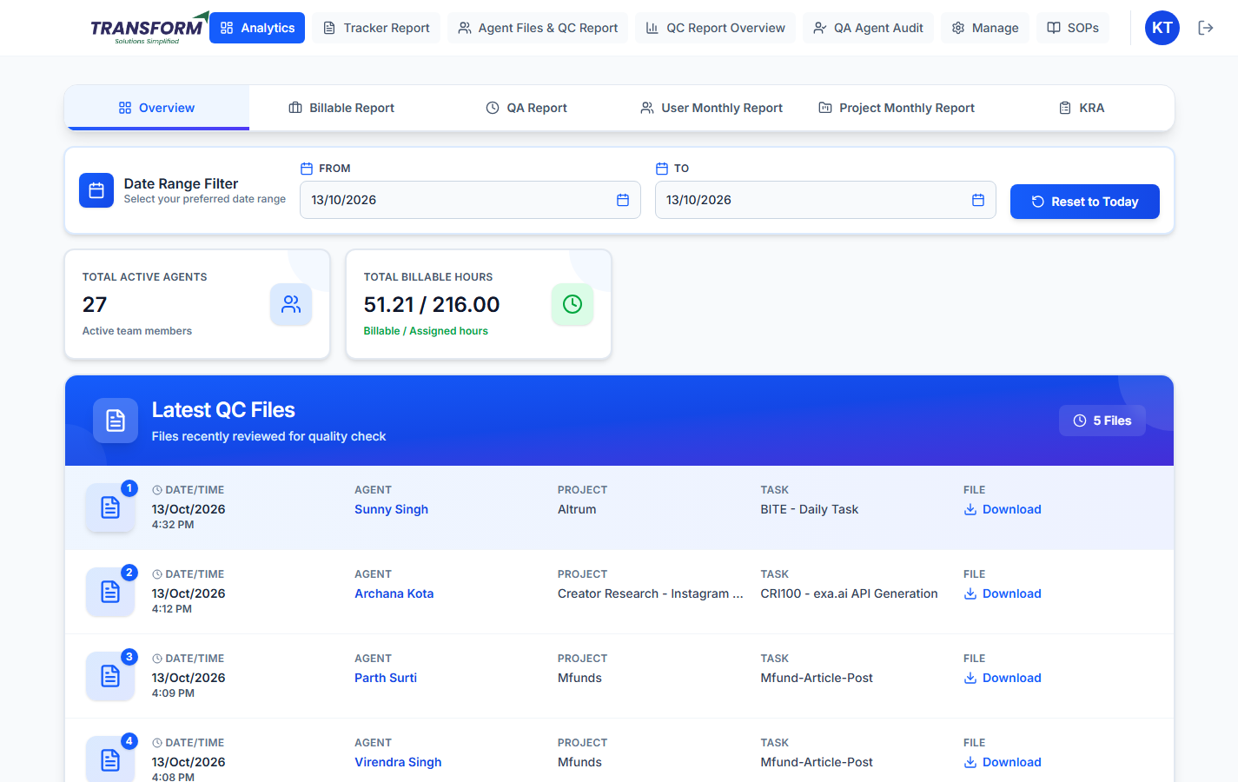
Figure 1: Overview - date filter and summary cards

2.1 Date Range Filter
1. Overview opens on today (From and To are both today's date).
2. Pick a From and a To date to see a longer period, for example the whole week or month. The cards and the file list reload straight away.
3. Click Reset to Today to go back to today.

2.2 The cards
Card | What it shows | How it is worked out
Total Active Agents | How many people worked in the selected dates. | Counts each person who added at least one tracker entry in those dates (each person once). People on leave or with no tracker entry are not counted, so on a holiday it can be low.
Total Billable Hours | Billable hours / Assigned hours, for example 51.21 / 216.00. | Billable = total billable hours from the tracker entries in those dates. Assigned = total assigned hours of those people on the days they worked (the same assigned hours shown in the Billable Report).

- A big gap between billable and assigned hours means trackers are missing or production is low. Open Billable Report > Daily Report to see which agent and which day.
- Assigned hours come from the roster and the daily assigned hours. If a person shows the wrong assigned hours, check their roster day first.

2.3 Latest QC Files
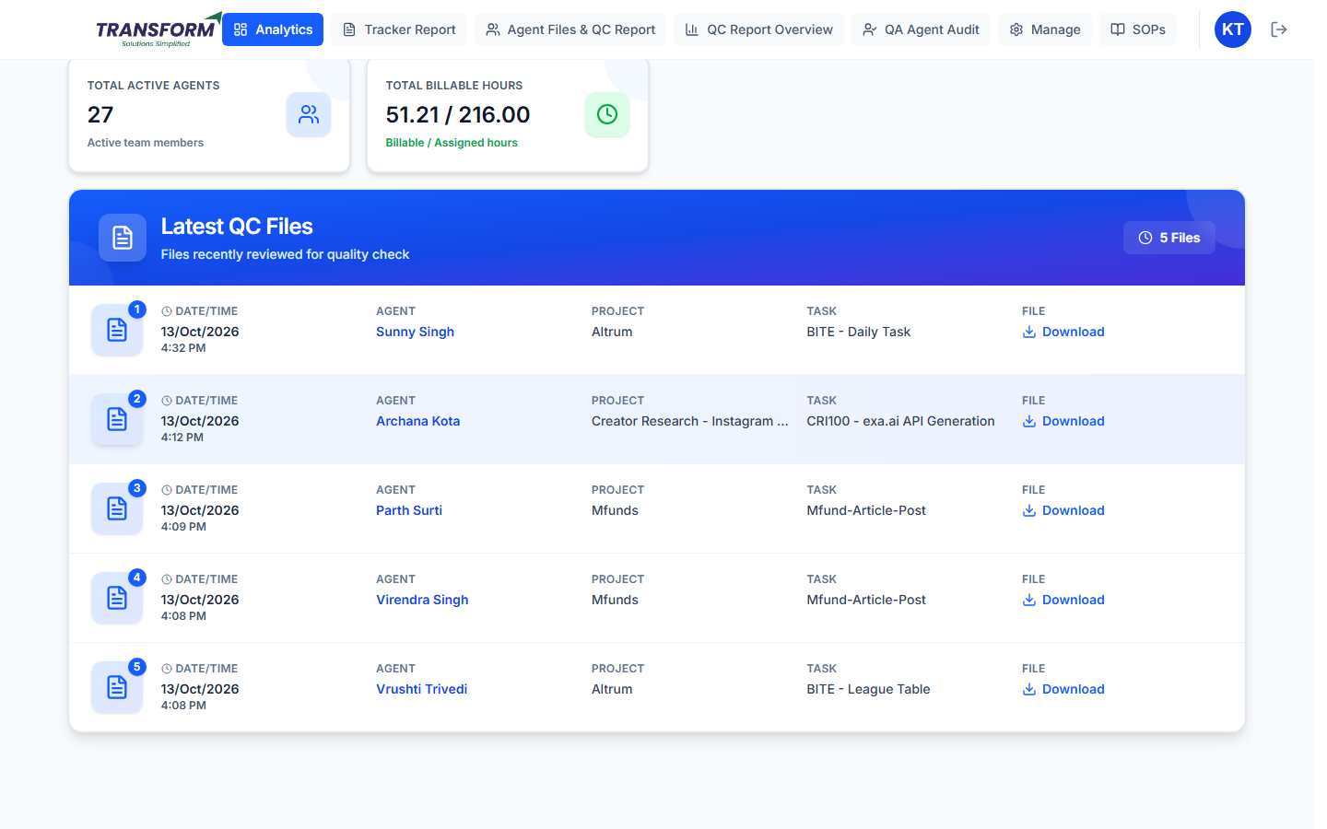
Figure 2: Latest QC Files
The five most recent tracker entries in the selected dates that have a file attached, newest first. Each row shows:
Column | Meaning
Date/Time | When the agent added the tracker entry.
Agent | Who uploaded the file.
Project / Task | The project and task of the entry.
File - Download | Downloads the agent's uploaded file so you can open it.

This list shows the latest uploaded files, whether or not QA has checked them yet. To see QC results and scores use QC Report Overview (see SOP - Manager - QC Report Overview and QA Audit).

2.4 What each role sees
Role | People included
Admin, Super Admin, Project Manager | All active users.
Assistant Manager / Assistant Team Leader | Only the people assigned to you (your team).

3. Billable Report

3.1 Daily Report
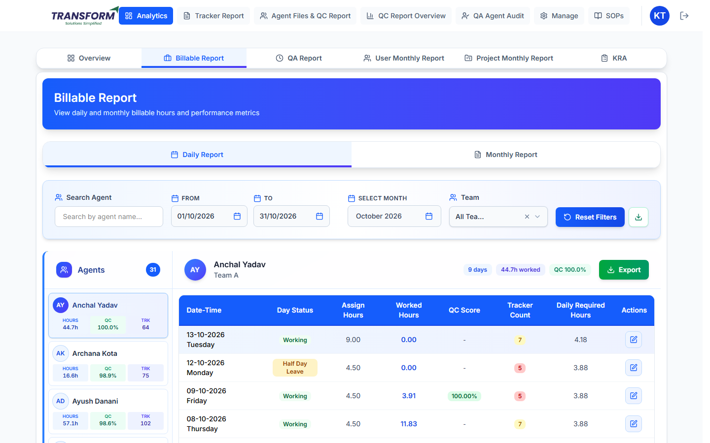
Figure 3: Daily Report - agent list and the selected agent's days
1. Filter with Search Agent, From / To, Select Month and Team. Reset Filters clears them; the download icon exports all agents' days (with Tenure for admins and managers).
2. Click an agent on the left (hours, QC and tracker count shown) to see their days: Day Status, Assign Hours, Worked Hours, QC Score, Tracker Count and Daily Required Hours. Export downloads that agent.
3. To correct a day's assigned hours click the edit icon, change Assign Hours and click Update Entry.
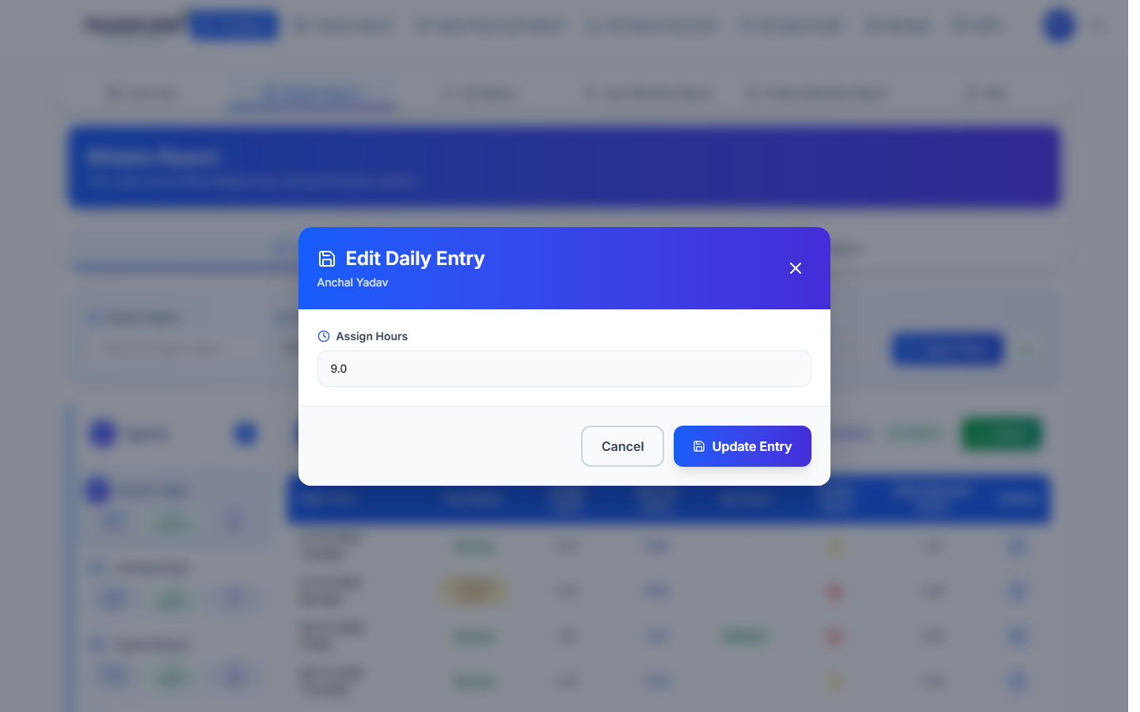
Figure 4: Edit Daily Entry

3.2 Monthly Report
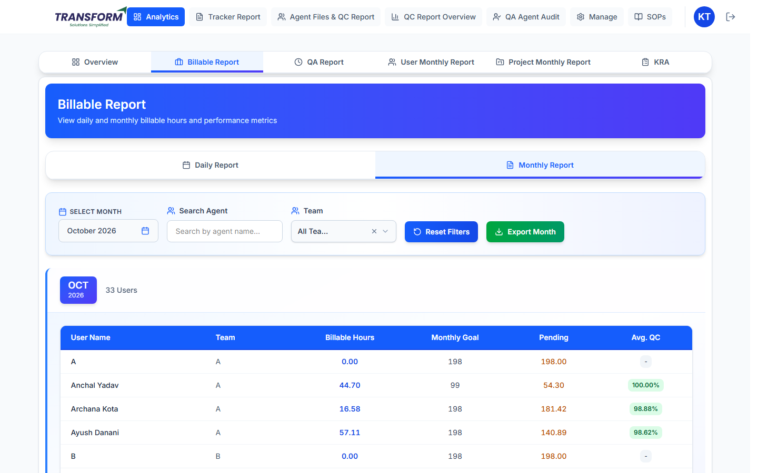
Figure 5: Monthly Report
Per agent: Billable Hour Delivered, Monthly Goal, Pending Target and Avg. QC Score. Export Month downloads the table (with Tenure for admins and managers).

4. QA Report
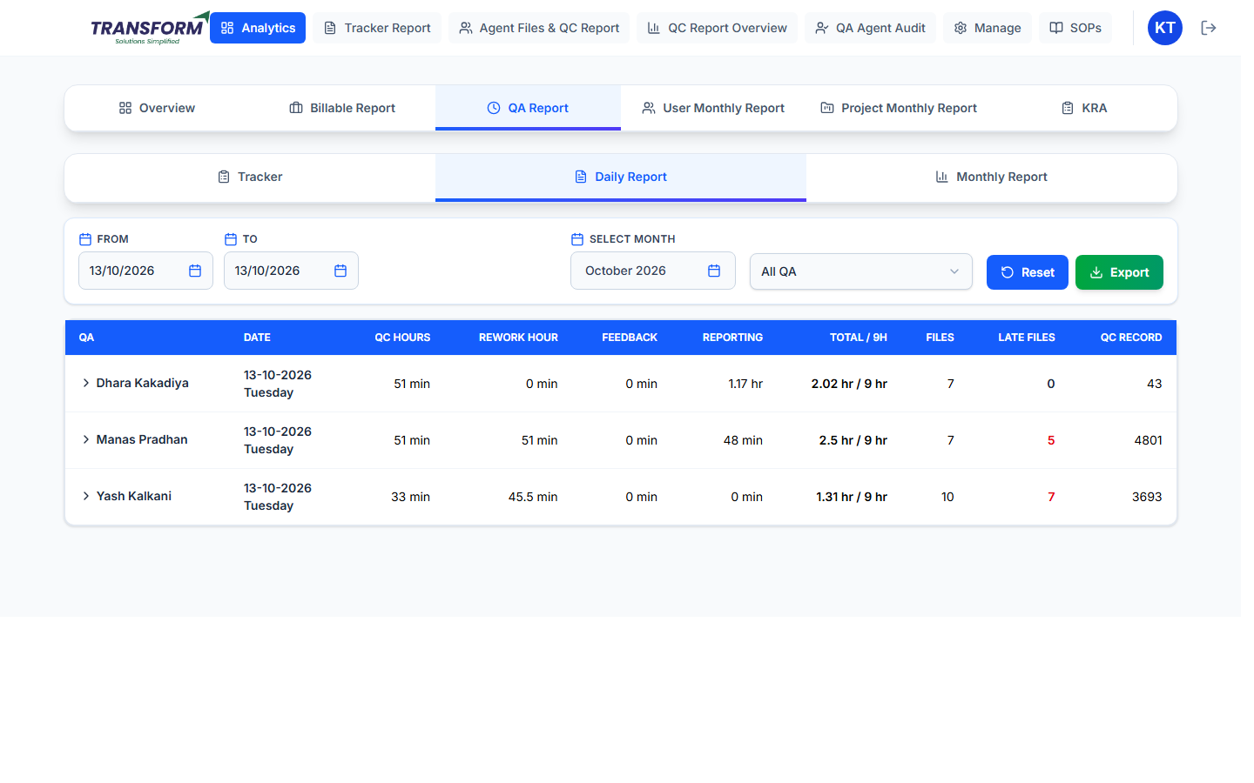
Figure 6: QA Report - Daily Report
- Tracker: QA's non-QC work entries. Daily Report / Monthly Report: QA hours per day / month.
- Columns: QC Hours, Rework Hour, Feedback, Reporting, Total / 9H, Files, Late Files (QC done after the deadline) and QC Record. Filter by dates, month and QA; Export downloads it.
- QC hours come from the task's QA hour criteria (see SOP - Manager - Projects and Tasks).

5. User Monthly Goal
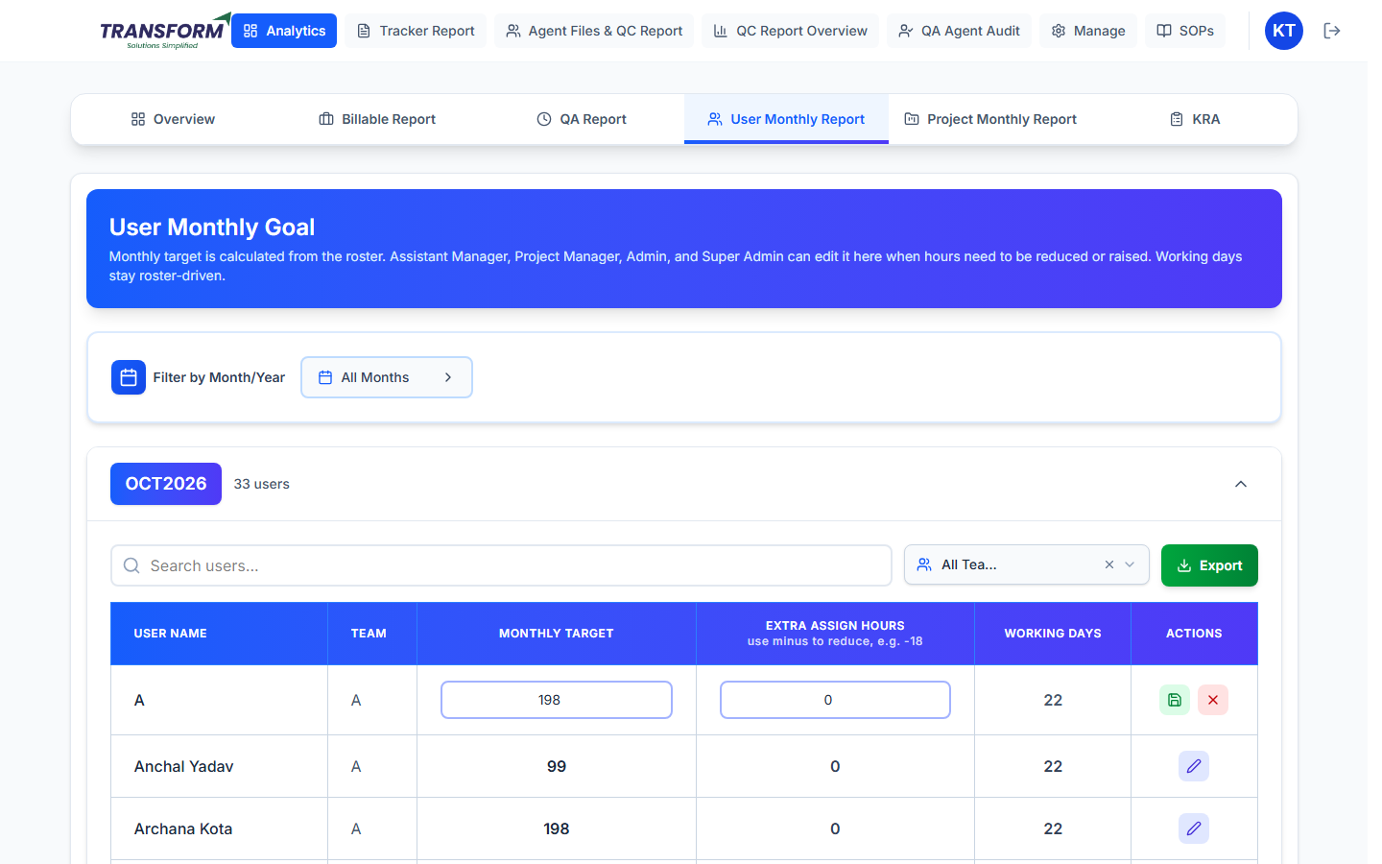
Figure 7: User Monthly Goal - editing a row
1. Pick the month (or All Months). Each month lists users with Team, Monthly Target, Extra Assign Hours and Working Days (from the roster).
2. Click the pencil to edit Monthly Target and Extra Assign Hours. Use a minus value (for example -18) to reduce the goal. Save with the green tick or cancel with x.
3. Search users, filter by team and Export the month.
- Monthly Goal = Monthly Target + Extra Assign Hours. It cannot go below 0.

6. Project Monthly Report
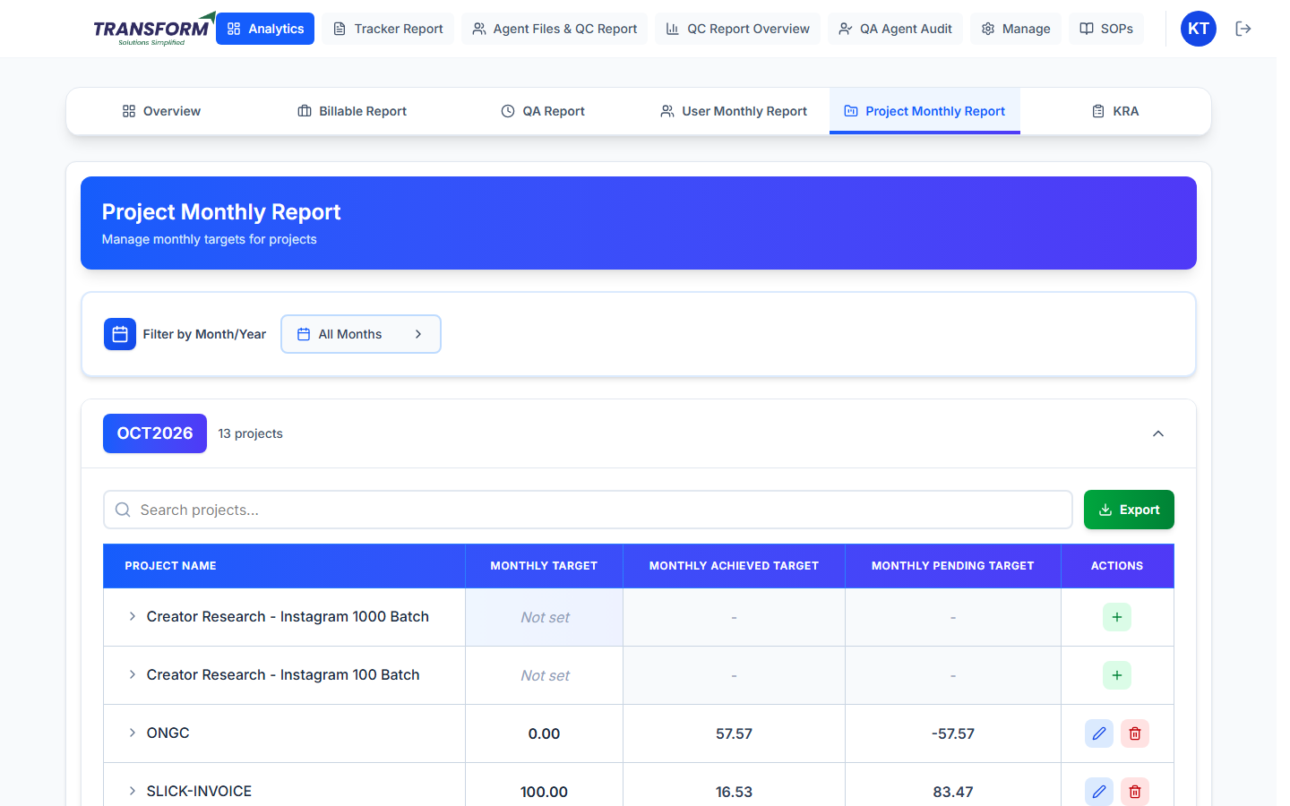
Figure 8: Project Monthly Report
Monthly hours and targets by project.

7. KRA
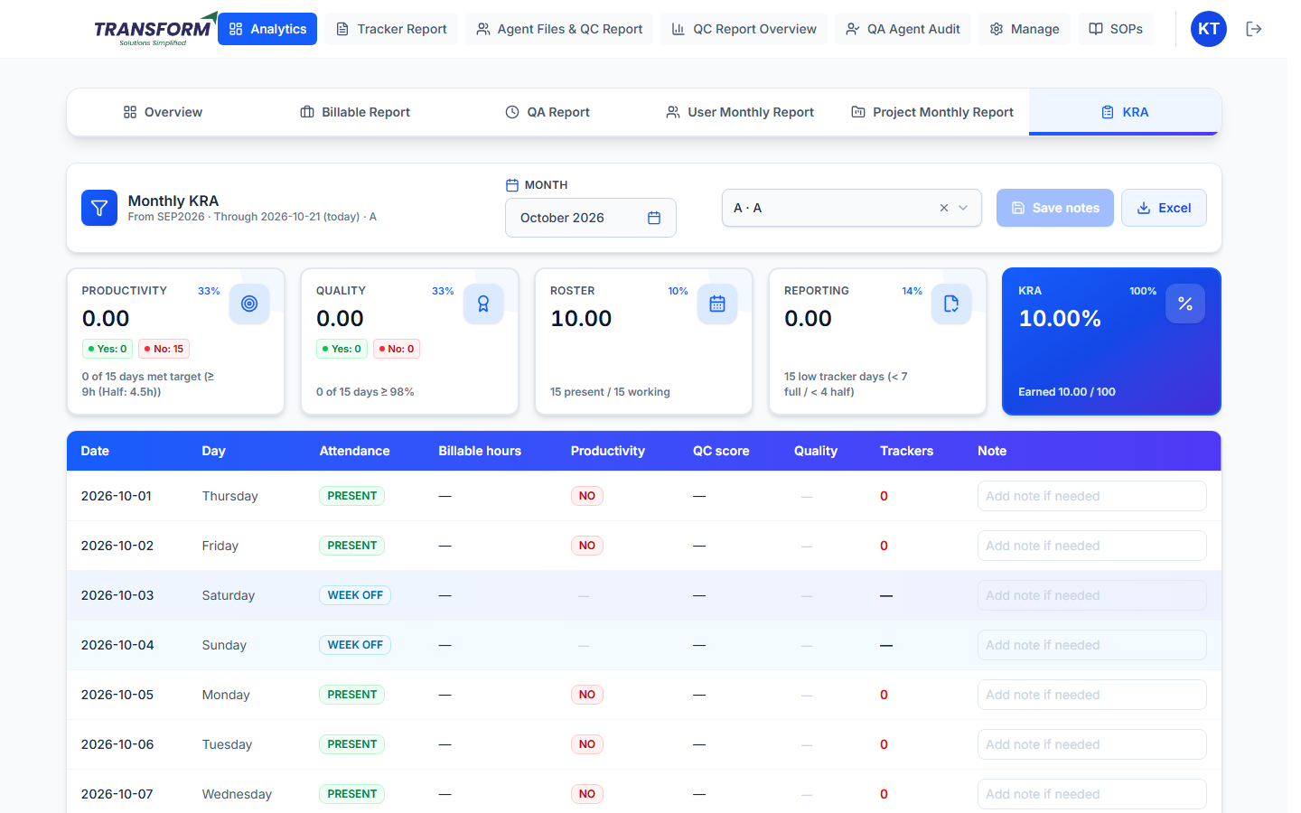
Figure 9: KRA - choose the person
- Choose the Month and the person. Cards show Productivity 33%, Quality 33%, Roster 10%, Reporting 14% and the KRA %.
- The table lists every day: attendance, billable hours, productivity, QC score, quality, trackers.
- Add a note on any day and click Save notes. Excel downloads the KRA.

8. Tracker Report - view and correct entries
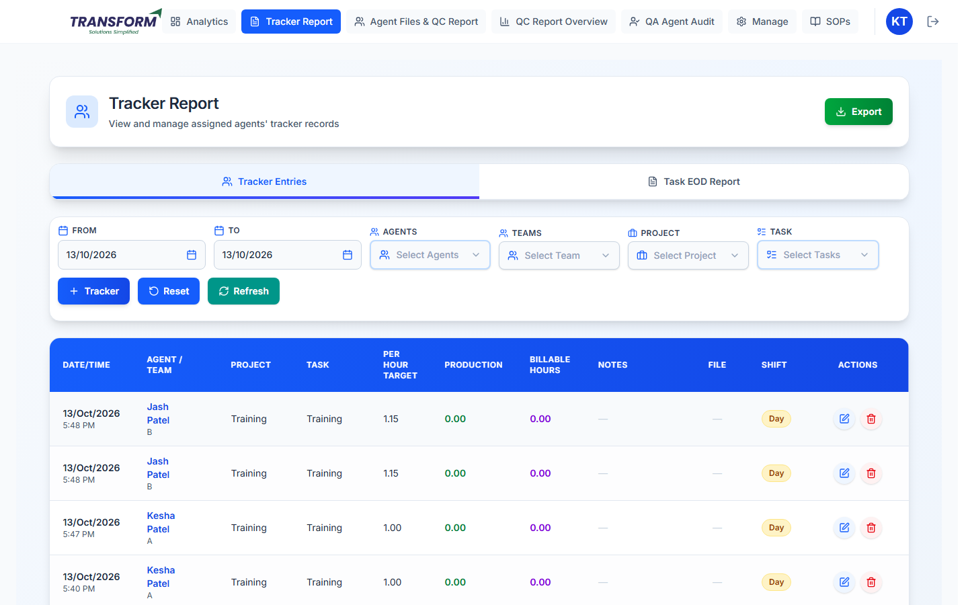
Figure 10: Tracker Report
1. Filter by Agents, Team, Project, Tasks and dates. The table shows every entry with target, production, billable hours, notes, file and shift. Export downloads the filtered list; Refresh reloads it.
2. Edit (pencil): change the date and time, project, task, shift, production, notes or file, then Update Tracker.
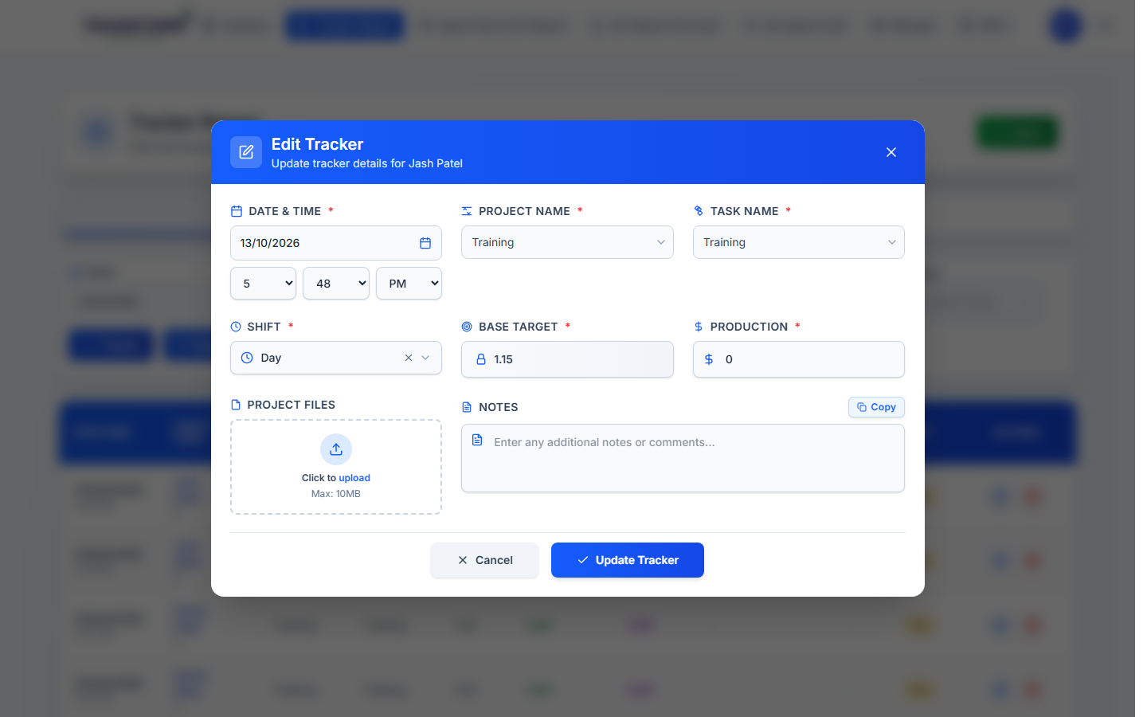
Figure 11: Edit Tracker
3. Add Tracker: add an entry for an agent (choose the agent first).
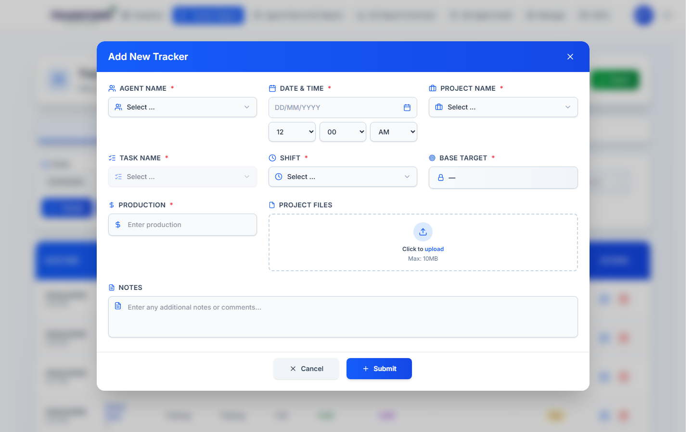
Figure 12: Add a tracker for an agent
4. Delete (bin): remove a wrong entry. This also removes its file and recalculates the day.

9. Tracker Report - Task EOD Report
The Task EOD (end of day) Report joins all agents' files for one task on one day into a single Excel file, with duplicate rows removed. Use it to send the client one consolidated file per task per day instead of collecting each agent's file.
Everyone except agents can open it: Admin, Super Admin, Project Manager, Assistant Manager, Assistant Team Leader and QA. It lists every project's tasks, not only your team's.
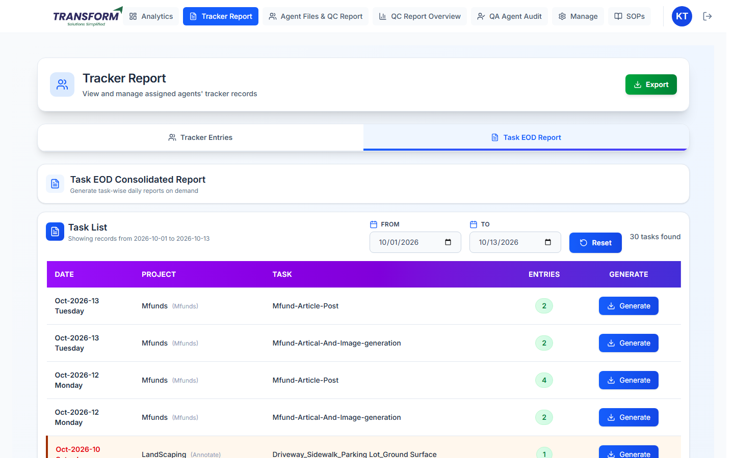
Figure 13: Task EOD Report - Task List

9.1 Find the task and day
1. Open Tracker Report and click the Task EOD Report tab (next to Tracker Entries).
2. The Task List loads by itself for this month (1st of the month to today). Change From and To to look at other dates; Reset goes back to this month. The number of tasks found is shown on the right.
3. Each row is one task on one day: Date (Saturdays and Sundays are shown in red), Project (with its code), Task, Entries (how many tracker entries that day) and Generate.

9.2 Check the entries before generating
1. Click the green Entries number. The Tracker List opens for that task and day and shows Total, Valid and Excluded counts.
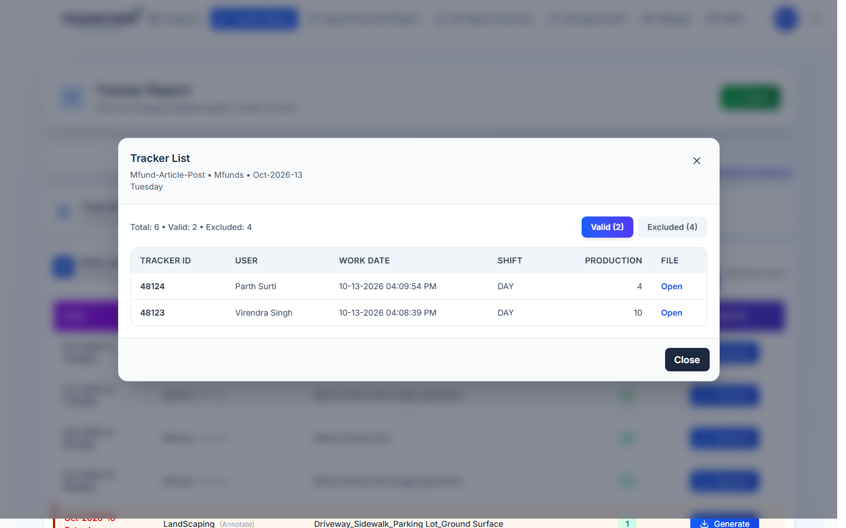
Figure 14: Tracker List - Valid entries
2. Valid: entries whose files will go into the report. Each row shows Tracker ID, User, Work Date, Shift, Production and the File (Open shows the agent's file).
3. Excluded: entries that will NOT go into the report, with the Reason. Fix these before generating if they should be included.
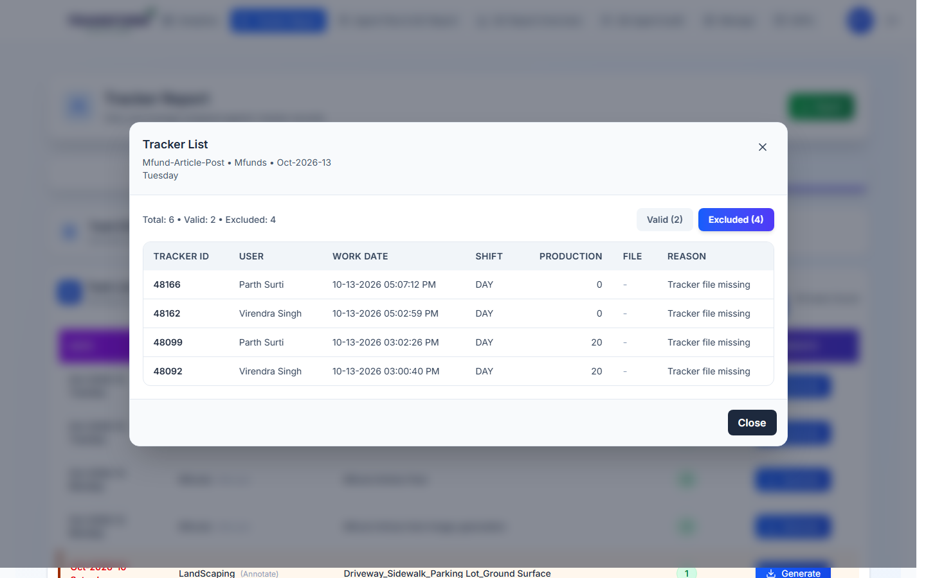
Figure 15: Tracker List - Excluded entries and reasons
4. Click Close to go back to the Task List.
Reason shown | What it means / what to do
Tracker file missing | The agent added the entry without a file. Ask the agent to add the file, or add it from Tracker Entries > Edit.
Inactive | The entry was deleted. Nothing to do unless it was deleted by mistake.
Actual target missing / Tenure target missing / Tenure target is 0 | The task had no target when the entry was added. Set the task's target in Projects and Tasks, then delete the entry and add it again (Tracker Entries > Add Tracker) so the target is picked up.
File not found on Cloudinary / File unreachable on Cloudinary | The file link is broken. Ask the agent to upload the file again.

9.3 Generate the report
1. Click Generate on the row. The button shows Generating... while the files are joined.
2. The Excel file downloads as EOD_Report_<task name>_<date>.xlsx. It has two sheets: Consolidated Report (all valid files joined, with user_id, user_name and work_date added to each row) and Tracker List (every entry with a file, marked accepted or rejected with the reason).
3. Rows that are the same in all of the task's Important Columns are kept only once, so the same record uploaded twice (even by the same agent) appears once.
- A task appears in the list only when it has Important Columns set (Projects and Tasks > Edit Task) and at least one entry with a file and a target.
- If any valid file cannot be downloaded, no report is made. A message lists the tracker IDs and agents whose files are missing; ask them to upload again and click Generate again.
- The report is made each time you click Generate and is not saved in the HRMS. Generate it again after any tracker is corrected.

10. Weekly goal email (every Monday)
Every Monday at 11:00 the HRMS emails last week's (Monday to Sunday) agents of teams A and B who did not reach their weekly goal. Nothing has to be opened in the HRMS; it arrives in your mailbox.
You are | You receive
Admin or Project Manager | All agents of teams A and B.
Assistant Manager or Team Lead | Only the agents assigned to you (Assistant Manager / Team Lead in the agent's profile). No agents assigned: no email.

- Week goal = Monday to Friday working days at the agent's daily hours (9 h x tenure), minus holidays, half days and leave that affects the target. Leave that does not affect the target still counts in the goal. Example: 45 h; 36 h with one full-day leave that affects the target.
- Achieved = billable hours from the agent's tracker entries that week (same as the Billable Report).
- For each agent who missed: week goal, achieved, shortfall and % achieved. Red below 75%, orange 75 to 89%, green 90% and above.
- If every agent reached the goal you get an "all achieved" email instead.
- Agents who left during the week are still included for that week.

11. Rules to remember
- Billable report exports include a Tenure column for Admin, Super Admin, Project Manager and Assistant Manager.
- Working days come from the approved roster; change the roster, not the report, for attendance.

12. Common problems
Problem | What to do
Numbers look wrong for a day | Check the roster for that day and the agent's tracker entries.
Edit icons not shown | Your role can view only.
Goal is wrong | Edit Monthly Target / Extra Assign Hours in User Monthly Goal.
Total Active Agents looks low | It counts only people with a tracker entry in the dates. Widen the dates or check who has not added trackers.
A task is missing from Task EOD Report | Set its Important Columns, and check the entries have a file and a target.
Generate says files were not found | Ask the listed agents to upload their files again, then Generate again.
No weekly goal email on Monday | Check Junk / Other. Team Leads and Assistant Managers get it only if agents are assigned to them. Ask the HRMS team to resend that week.
An agent's week goal looks wrong | Check that week in the roster: leave marked as affecting the target, half days and holidays reduce the goal.

